Project #3 – MPI Reduce & Broadcast  
Kyle Pontius

# Introduction

The dawn of the transistor, and with it, the computer has brought on arguably the greatest age of innovation and technological growth this world has ever seen. Few lives have remained untouched by this relatively new and extraordinary development. One computer alone holds untold power, yet tethering these machines together helps us reach new heights unachievable with single units. MPI is one of the most powerful, modern tools we have to create such a network of machines. The principle of this project is to flex MPI’s communication muscle to create a meaningful example using vector max reduce & broadcast.

# Methods

To facilitate efficient communication between our nodes, for vector max reduce & broadcast, we use the hypercube approach; which acts much like a binary tree and functions with logarithmic behavior. Broadcasts begin at the root node, then uses MPI_Send() to message two children. This pattern repeats for each segment of the hypercube, where each child node then sends to two new children nodes of its own (hence the logarithmic growth). This is also the pattern of reduction, where two children reduce to a single parent, with each parent in turn reducing with another parent until the root node is reached.

My approach was to create a program which does the following: First, each machine generates a new array of random numbers (size n). Second, the node takes the two arrays that are reduced (sent) to it, then chooses the highest value at a given position, from either array, then assigns that as the result in its final result (on the first iteration, this skips directly to step 3 since we only have one array to compare). Third, the array reduces, or in other words sends, its now maximized array to the designated parent node “below” it. Finally, after all the child nodes have reduced to their parent nodes, we end up at the root node, where the final array contains the maximum value 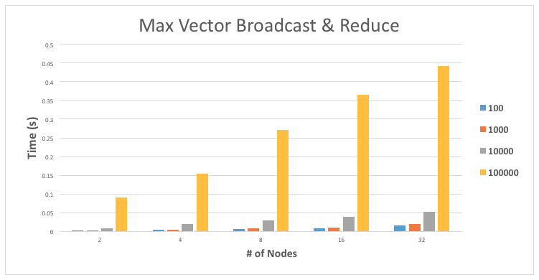for each position in the array, over all nodes in the tree.

# Results

General performance results from my algorithm are charted above. This graph depicts the execution time of different problem sizes, ranging from 100- to 100,000- sized arrays of randomly generated integers. These numbers show us some very interesting results, a few of which I’d like to touch on.

First, for a given number of nodes, say 32, the execution time takes almost 10x longer for each array-size respectively. In other words, the time for a 10,000-sized array to execute on 32 nodes takes 10x less than 100,000. This is interesting because it shows us that the communication time is nearly constant, or at least that there’s no significant difference between the two array sizes.

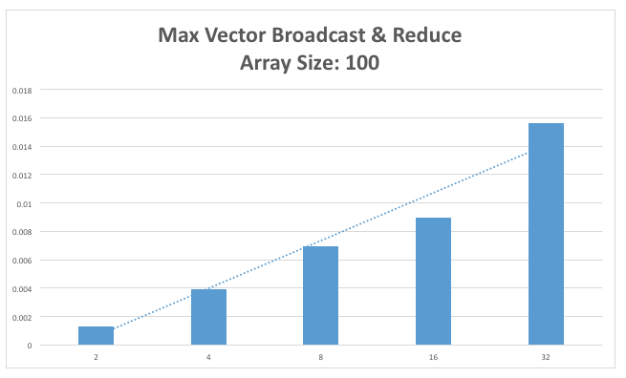Second, observe the difference in speed for each vector size, for a given number of nodes. The coefficient of growth between for problem size 1000 on 2, 4, 8, 16, and 32 nodes is nearly identical to the scale of growth on problem size 100,000 for 2, 4, 8, 16, and 32 nodes. Again, I believe this attests to the fact that communication time between the nodes is not the primary factor in increasing execution time. However, this leads us to the final point I’d like to make.

While I did my best to make the communication time dominate the calculation time of the program, I just couldn’t do it. In an attempt to scale down execution time to be smaller than communication time I dropped the array size to just 100 integers. However, this didn’t change the execution time growth coefficient at all (see graph just above). As we can see from this graph, and the linear trend line I added, the growth of the execution time was nearly linear. If I had to surmise the reasoning behind these results, and the failure of communication time to affect the outcome, I would guess that if we drastically increased the number of nodes or shrunk the problem size even further, we’d finally observe a more significant impact from communication on total runtime. Additionally, the low communication time could also be simply due to the type of problem we’re dealing with, that is, we’re just passing arrays back and forth. This is probably far different than moving large, unconventional, data objects around instead.

# Conclusion

First, this particular problem is dominated by problem size far more than communication time. Second, execution time grew, for each problem size, with a nearly identical growth coefficient; which is to say that each time we increased from 2, to 4, to 8, and so on nodes, our execution time growth was proportionally very similar for both a 100-sized array and a 100,000-sized array. Finally, despite shrinking the problem size down to a relatively small number, we saw that communication time between nodes was still insignificant. We could potentially increase the number of nodes significantly or simply change the problem type to observe a scenario where communication time dominated total execution time.